Stage 3 Physics:
Particles, Waves and Quanta Student Workbook One
Outcomes 1 to 11

Name: TEACHER’S GUIDE

Description:
The unit content organisers are particles, waves and quanta Study of mechanical and electromagnetic waves allows students to extend their understanding of the nature and behaviour of waves. They analyse spectra and explain a range of physical phenomena such as fluorescence and X-ray emission. They also learn about some topics of modern physics such as relativity and cosmology.

Contexts:

Within the unit content organisers of particles, waves and quanta teachers must present the unit content through one or more contexts, such as the following (this list is not exhaustive):

Student unit learning contexts for particles, waves and quanta may include:
- medical imaging and therapies
- colours of fireworks
- sunlight and starlight
- sonar and echo-location
- optical fibres
- musical instruments
- communication systems
- security/remote sensing systems.

Working in physics

Students research and report on a question relating to a real world problem. They develop problem-solving strategies that involve linking a number of concepts and principles. They consider the level of absolute and percentage uncertainty in experimental measurements and conclusions.
This includes the use of error bars when displaying data and conclusions graphically.

Plan For Unit.
This workbook will give you an outline of the content to be covered and the related text pages. It is not intended to be used alone but in conjunction with your text and teacher. It is expected that you will follow the workbook and read the related text, experiments and investigations before the lesson. It will be assumed that you have read the text and have some introductory knowledge of the work to be covered each lesson; failure to do so may affect your progress in class. Your teacher will then teach you the concepts and show you how to do the examples in the workbook thus ensuring you have exemplars when completing additional questions from the workbook and texts. Your teacher also has all the worked answers to the additional questions in this workbook and you must check your answers when you complete the questions.

In addition to the work set for homework, it is essential that you set up a study plan and regularly review the work covered. This plan should be set up from day one. Regular reviewing not only makes study easy, it ensures good grades.

Week | Content | Exploring Physics |  | Assessments
Week | Content | Possible Problem Sets | Possible Experiments & Investigations | Assessments
8 | Review Examination  Particles, waves and quanta  - explain and apply the concepts of amplitude, frequency, wavelength, displacement and speed of longitudinal and transverse mechanical waves—including applying the relationships: 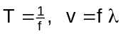 | Set 9: Waves | Expt: 9.1  Expt: 9.2  Expt: 10.1 | Task 2: Validation of research topic e.g. make a mind map of your research in class.  Topic: e.g.  Receiving and transmitting antennas
9 | - explain and apply the concepts of reflection, refraction and diffraction of wave fronts  - explain and apply the concepts of free oscillations, forced oscillations, interference and standing waves—this will include identifying nodes and antinodes, using the expression internodal distance = ½ λ  - sketch diagrams to illustrate the behaviour of waves in a variety of situations | Set 10: Wave Behaviour | Expt: 10.2  Expt: 10.3  Possible:  Expt: 10.4  Expt: 10.5
10-11 | - describe and explain the nature and properties of electromagnetic waves, including the concept of light as a wave of changing electric and magnetic fields, and its wave and particle properties  - describe and apply electromagnetic radiation and the emr spectrum  - classify emr spectra as emission spectra and absorption spectra and as line, broadband and continuous spectra  - describe and explain how astronomical observations exploit differences in properties of the various parts of the emr spectrum in order to gather more information about celestial bodies | Set 11: Photons | Expt: 11.1  Expt: 11.2  (demo)  Expt: 11.3  (demo)
Term 3 Particles, waves and quanta continue
1 | - explain and interpret line emission spectra, line absorption spectra and ionisation using the Bohr model of the atom and the concepts of ground and excited states, photons, quanta and energy level transitions—this includes applying the relationships: c = fλ, E = hg, E₂ – E₁ = hf  - explain fluorescence and the generation of X-rays—this includes applying the relationships: 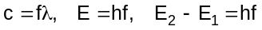 | Set 12: Atoms and X-rays | Expt: 12.1  Expt: 12.2  Invest: 12.3  Invest: 12.4  (home research)
2-3 | Workbook Two  - extend concept of subatomic particle to include neutrinos and quarks  - describe the qualitative aspects of the special theory of relativity such as reference frames and the mass-energy equivalence principle  - apply the speed of light in vacuum to astronomical distances to predict and explain transit times of light and particles travelling between planets, stars and galaxies—this will include applying the relationship: 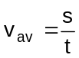  - describe and explain the expansion of the Universe and Hubble’s law  - describe and explain fundamental cosmological concepts such as red shift, the Big Bang Theory and the history and future of the Universe  - describe and explain the importance of particles, waves and quanta in everyday life. | Set 13: charged Particles in Electric Fields | Expt: 13.1  (demo)  Expt 13.2  (demo)  Invest: 13.3  (home research) | Task 9: Test Particles, waves and quanta
Assessment outline: Stage 3 PHYSICS
Outcome 01: Investigating and Communicating in Physics;
Outcome 02: Energy;
Outcome 03: Forces and Fields

Assessment type | Assessment type weightings | Tasks | Content | Outcomes coverage |  |  | Weighting  %
 |  |  |  | O1 | O2 | O3 | 3A | 3B | Total
Experiments and investigations  (20-40%) | 21% | Task 1: Practical exam (3A) | Practical exam on 3A experiments and investigations |  |  |  | 5 |  | 5
Experiments and investigations  (20-40%) | 21% | Task 2: Research topic | Validation activity on student research (written report) |  |  |  |  | 3 | 3
Experiments and investigations  (20-40%) | 21% | Task 3: Extended Investigation | Extended investigation |  |  |  | 4 | 4 | 8
Experiments and investigations  (20-40%) | 21% | Task 4: Practical exam (3B) | Practical exam on 3B experiments and investigations |  |  |  |  | 5 | 5
Tests and Examinations  (60-80%) | 79% | Task 5:Validation tests on Assignments, Problem Sets and Homework | Accumulation of validation tests on Assignments, Problem Sets and homework |  |  |  | 2 | 2 | 4
Tests and Examinations  (60-80%) | 79% | Task 6: Test Projectile Motion | Test on projectile motion |  |  |  | 3 |  | 3
Tests and Examinations  (60-80%) | 79% | Task 7: Test Motion and forces in a gravitational field | Test on Motion and forces in gravitation al field |  |  |  | 4 |  | 4
Tests and Examinations  (60-80%) | 79% | Task 8: Test electricity and magnetism | Test on Electricity and Magnetism unit |  |  |  | 6 |  | 6
Tests and Examinations  (60-80%) | 79% | Task 9: Test Particles, waves and quanta | Test on Particles, waves and quanta unit |  |  |  |  | 6 | 6
Tests and Examinations  (60-80%) | 79% | Task 10: Test Motion and Forces in Electric and Magnetic Field | Test on Motion and Forces in Electric and Magnetic Field unit |  |  |  |  | 6 | 6
Tests and Examinations  (60-80%) | 79% | Task 11: Semester One Examination | Examination on 3A |  |  |  | 20 |  | 20
Tests and Examinations  (60-80%) | 79% | Task 12:Stage 3 Examination (includes 20% of 3A) | Examination on Stage 3 work |  |  |  | 5 | 25 | 30
TOTALS |  |  |  |  |  |  | 50 | 50 | 100

Outcome 1
Explain and apply the concepts of amplitude, frequency, wavelength, displacement and speed of longitudinal and transverse mechanical waves—this will include applying the relationships:

WAVES:
A wave is a disturbance which progresses from one point in a medium to another, without the transport of matter. The characteristics of wave motion are:
- energy is needed to set up a wave.
- particles in the medium execute relatively small vibrations about their mean positions but suffer no permanent displacement.
- successive particles perform similar motions but slightly delayed in time (energy transferred as wave progresses).

Mechanical waves are those which require a physical medium e.g. sound and water.
Electromagnetic waves do not require a medium e.g. light, radio waves.

TYPES OF WAVES

Transverse Waves
Wave motion in which the particles of the medium vibrate perpendicular to the direction of energy transfer. The information on the back of this sheet shows the formation of a transverse wave.

Longitudinal Waves
Wave motion in which the particles vibrate left and right in the direction of energy transfer.

(NOTE: Water is actually a special wave type – a mixture of the two, but is considered transverse in this context.)

Questions:
- Explain how a mechanical wave is different from an electromagnetic wave and give examples of each.
Mechanical waves need a medium e.g. sound waves in air
Electromagnetic waves do not need a medium e.g. light waves from the sun to the Earth
- Explain the difference between the motion of the particles in transverse and longitudinal wave. Diagrams may help.
Transverse waves - particles move perpendicular to direction of energy transfer
wave energy motion of particles.

Longitudinal waves – particles move parallel to direction of energy
wave energy motion of motion of particles

- What similarities and differences exist between longitudinal and transverse waves?
Similarities – both transfer energy, particles not permanently displaced, both periodic movement
Differences – direction of motion

PERIODIC WAVES
Disturbances which are single and non-repeating are called pulses. Disturbances which are repeated on a regular basis are termed periodic waves. The simplest form of vibratory motion is simple harmonic motion (SHM). The oscillations of a pendulum and the vibration of a single particle in a wave motion are examples of SHM.

A particle vibrating with SHM has the following characteristics:
- it vibrates about an equilibrium position.
- at maximum displacement, velocity equals zero.
- at zero displacement, velocity is a maximum.

TERMINOLOGY
Displacement (s): the distance from equilibrium position
Amplitude: the maximum displacement of the wave
Phase: the position and motion at any instant
Period (T) time taken for one complete wave cycle
Frequency (f) number of cycles per second (called pitch in music)
Wavelength (λ) the distance between two consecutive points in the same phase of wave.
Wave velocity (v): the velocity of the disturbance or wave through the medium.
Compression: maximum forward displacement of particle } associated with
(high pressure region) } longitudinal
Rarefaction: maximum reverse displacement of particles } waves
(low pressure area) }
Crest: maximum vertical (upward) displacement of particles } associated with
Trough: maximum vertical (downwards) displacement of } transverse
particles } waves

WAVE GRAPHS.
A wave can be displayed on a graph as shown below:
Displacement / distance graph - Your teacher will draw this graph for you to copy.
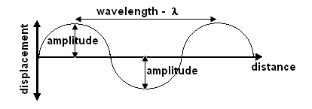
This graph shows wavelength and amplitude

shows many particles -
as if a still picture have been
taken of the wave

Displacement / time graph Your teacher will draw this graph for you to copy.
This graph shows the period of a wave
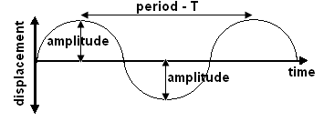
shows one particle only -
as if a video has been
taken of the particle

Question:
Explain why a different type of information is conveyed by a displacement-time graph in comparison with a displacement-distance graph.
Displacement-time graph shows the journey of only one particle and how long it takes (period) to complete the wave cycle.
Displacement-distance graph shows all the particles in that wave and hence the length of the wave (wavelength)

Outcome 2
Explain and apply the concepts of reflection, refraction and diffraction of wave fronts.
Outcome 4
Sketch diagrams to illustrate the behaviour of waves in a variety of situations.

WAVE FRONT
A wave front represents all particles in the medium which are in the same phase, ie. all the crests (or troughs) or all the compressions (or rarefactions).

A ray is a line drawn perpendicular to the wave fronts showing the direction of propagation. Each successive wave front is a wavelength apart.
ray

wave fronts

WAVE BEHAVIOUR
Reflection:
All waves are reflected when they strike a barrier in their path. They are reflected such that they obey the law of reflection: the angle of incidence = the angle of reflection.

Your teacher will demonstrate how the waves are reflected in the following situations.

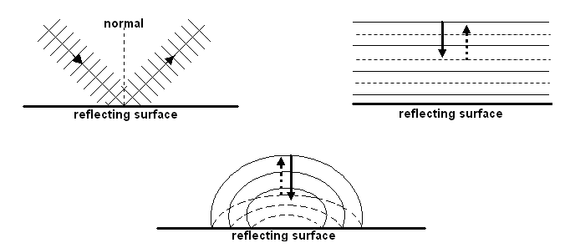
Refraction:

Refraction is due to a change in velocity as a wave passes from one medium to another with differing wave characteristics (e.g. more dense). The frequency of the wave remains unchanged but due to a change in velocity, the wavelength changes and a bending effect can be observed if the ray enters the new medium at any other angle than 90⁰. The relationship between velocities (or wavelengths) and angles of incidence and refraction are expressed in Snell’s Law.

Wave Formulas

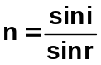 where: n₁ is the refractive index of the first medium
n₂ is the refractive index of the second medium
i is the angle of incidence
n₁ sin i = n₂ sin r (Snell’s Law) r is the angle of refraction
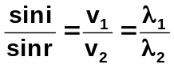 v₁ = initial velocity of wave
v₂ = final velocity of wave
λ₁ = initial wavelength
λ₂ = final wavelength

If the wave travels faster when it enters the new medium, it bends away from the normal e.g. sound waves travelling from air into water.

If the wave travels slower when it enters the new medium, it bends towards the normal e.g. light waves travelling from air into water.

Your teacher will help you to complete the following diagrams.

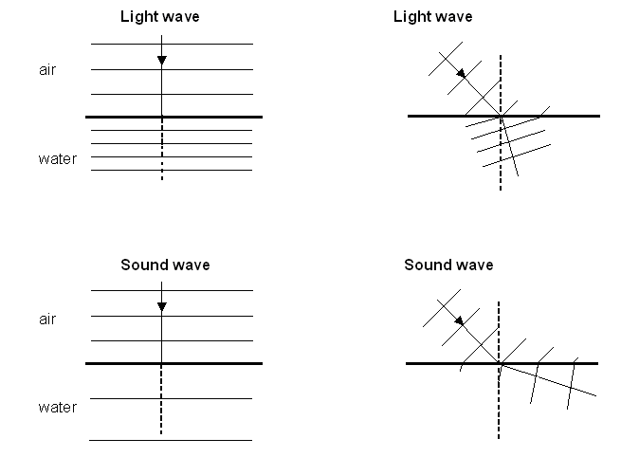

Diffraction:

Diffraction is the bending of waves as they pass through an opening or around the edge or edges of an obstacle. The amount of bending depends on the opening. If the wavelength is about the same as the opening then maximum diffraction will occur. This helps to explain why you can hear someone through a door (wavelength of sound similar to width of a door) but you can’t see them (wavelength of light very small). In addition, higher frequency sound waves have shorter wavelengths sod they will diffract less than lower frequency sound waves as lower frequency sound waves have longer wavelengths.

Your teacher will help you to complete the following diagram:

There is no movement in
the shadow region and
the size of the shadow
region is determined
by the width of the opening
and the wavelength. The
closer they are, the less
shadow region.

A Summary of Wave Behaviour

Behaviour | Cause | Unchanged | Changed | Application
Reflection | change in direction as wave strikes a boundary | v, λ, f | direction | echoes and reverberation
Refraction | change in speed of wave as a result of change in density of a medium | f | direction, λ, v (Snell’s Law) | zones of silence
Diffraction | change in direction as a result of a wave passing through a gap or around an edge | v, λ, f | direction | hearing around corners and through gaps

WAVE EQUATIONS:

The wave velocity is the velocity with which the disturbance moves through the medium. It is the product of the wavelength and the frequency.
v = fλ and T = where: v = wave velocity in m s⁻¹
f = frequency in Hz (s⁻¹)
λ = wavelength in m
T = period in s
Example:
Carbon dioxide is heavier than air. An experiment is set up which has a layer of carbon dioxide in a large container with a layer of air on top. The speed of sound in the carbon dioxide is 270 m s⁻¹ and in the air, 340 m s⁻¹. A 450 Hz sound wave travelling through the air strikes the boundary between the two gases at an angle of 40⁰. Find the wavelength in each gas and then the angle of refraction into carbon dioxide.
air: 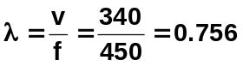 m s⁻¹ 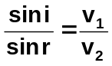 ; sin r = 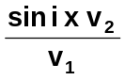
carbon dioxide: 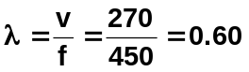m s⁻¹ sin r = 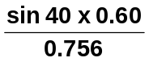 = 0.5101

r = 30.7⁰
Exercise: Look at the following wave.
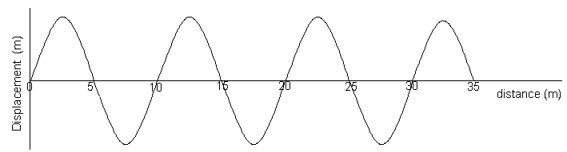

a. What is the wavelength of the wave above? 10 m
b. 10 waves pass every second. What is the frequency? 10 Hz (definition of frequency)
c. What is the time taken for 1 cycle (wave)? That is, what is the period? 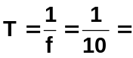 0.1 s
d. Calculate the speed of the wave (velocity of the wave)? v = λf = 10 x 10 = 100 m s⁻¹
e. On the axes below draw accurately the same wave as it would appear for the first 0.2 seconds.

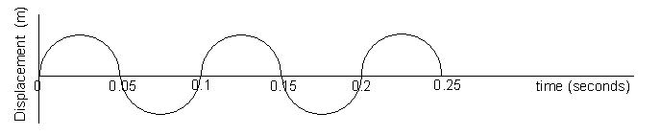

- Look at the following wave that has a velocity of 3.0 x 10⁸ ms⁻¹. Calculate the frequency and then use the chart in your data sheet to determine what type of wave it is.

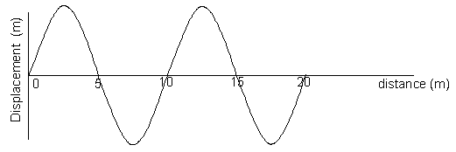
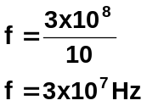

using data
sheet this is
radio waves

Exploring Physics Stage 3:
Possible Experiments and Investigations:
- Experiment 9.1: Making waves
- Experiment 9.2: Measuring the speed of sound
- Investigation 9.3: Measuring the speed

Set 9: Waves pages 107 to 108

- Experiment 10.1: Observing waves pg. 112 to 113

Do QUESTION SET ONE on the next page.
QUESTION SET ONE: Waves and Wave Behaviour ANSWERS ON PAGE 33

- An umpire blows his whistle when he is at the opposite end of a football ground from you. Estimate the time delay between the moment you see the whistle being blown and when you hear it.

- a. What does the term “displacement” mean when applied to sound waves.
b. Sketch graphs of displacement versus time for a low pitch graph and a high pitched graph.

- Do sound waves diffract? If you wanted to try and demonstrate that your answer is correct, how would you try to do this? Include a diagram with your answer.

- Some examples of waves are sound, radio, water waves, and X-rays. Classify these as either mechanical or electromagnetic waves.

- A person fishing from jetty notices that the foam float on their fishing line gently bobs up and down as regular waves pass by. The person counts 13 full oscillations of the float in one minute. What is the period of the wave?

- An example of a longitudinal wave is ______ An example of a transverse wave is _________
Explain the difference between longitudinal and transverse wave.

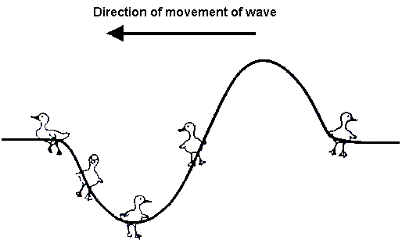
- Bridgette is watching some ducklings, which are paddling on a pond, when a wave approaches them. Use arrows to show direction of movement of each duckling at the instance shown on the diagram. If there is no movement, label “no-motion”.

- Draw a graph to illustrate amplitude and wavelength of a wave.

- Complete the following diagram to show reflection of sound from a circular reflector.

- On a calm summer evening the air near the ground is rather cool while higher up it is warmer. Sound travels faster in warm air. Using wave-front diagrams carefully show how refraction of sound can allow the noise from an aircraft to be heard quite clearly at some point far away.




Outcome 3
Explain and apply the concepts of free oscillations, forced oscillations, interference, resonance and standing waves—this will include identifying nodes and antinodes, and using the expression internodal distance = ½ λ.

INTERFERENCE OR SUPERPOSITION

Superposition or interference occurs when two waves overlap and interfere with each other.
Your teacher will give you the diagram that complete this section.

Constructive Interference: a resultant increase in amplitude.
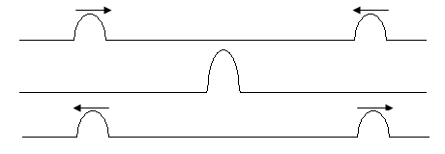
Destructive Interference: a resultant decrease in amplitude.
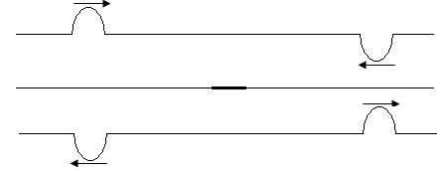

In general, a resultant wave is a mixture of both.
Waves on the same side are added together. Waves on the opposite side are subtracted.
Draw the resultant wave from these two waves.

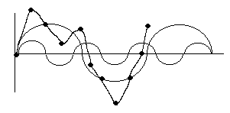

BEATS

Beats are a special case of interference. Beats occur when two waves of very similar frequencies interfere with each other. The differences in the frequencies are usually less than 10 hertz.

Beat frequency = frequency two - frequency one
f_{B} = |f₂ - f₁ |

See page 203 of your text for diagrams illustrating beats.

Example of Beats
At a rehearsal for a concert a guitar player uses a piano to tune her instrument. She plays a note on the piano which produces a frequency of 440 Hz. When the A string of the guitar is sounded at the same time, she hears four beats per second.
- At what frequency is the A string vibrating?

f_{b} = | f₁ – f₂ |
4 = | 440 – f₂ |
f₁ = 440 – 4 or 440 + 4
= 444 Hz or 436 Hz

- If the tension on the A string is reduced slightly she hears 1 beat per second when the string is played at the same time as the piano. At what frequency is the A string now vibrating?

reducing tension, reduces frequency
therefore 441 Hz

NATURAL AND FORCED VIBRATIONS
Whenever an object is struck, such as a tuning fork, and then allowed to vibrate without further interference, its vibrations are called free or natural vibrations. All bodies have a natural vibrating frequency and this depends upon their physical characteristics.

A body can also be forced to vibrate at a frequency which is not its natural frequency. Whenever this occurs we refer to it as a forced vibration. A typical example is a tuning fork placed on a bench. The bench is forced to vibrate at the frequency of the tuning fork and the sound is louder because of the larger vibrating surface area. The sounding box of a guitar also works in this way. The intensity of the sounds of all musical instruments is enhanced by the effect of forced vibrations.

RESONANCE
All objects have their own natural frequency of vibration. At this frequency an object will vibrate most vigorously. Resonance occurs when something forces a body to vibrate at its natural frequency. An example of this is a person being pushed on a swing. If applied and natural frequency are equal, the swing’s amplitude will increase. Another example is resonance in organ pipes and similar musical instruments to enhance the vibrations and hence the sound.

A few very good singer can cause a crystal wine glass to break when the singer sings a particular note. Explain why this occurs.

Singer’s voice forces the glass to vibrate. If the vibrations match the natural frequency of the glass, vibrations rapidly increase and glass breaks.

http://www.youtube.com/watch?v=Grvr_0K1p4M&NR=1
http://www.youtube.com/watch?v=P0Fi1VcbpAI
http://www.youtube.com/watch?v=JiM6AtNLXX4

REVERBERATION TIME
Reverberation is the echo effect in rooms. Reverberation time is the time for a sound to decrease in intensity by 60 dB. It depends on reflecting or absorbing properties of all the surfaces in the room.

STANDING OR STATIONARY WAVES

A standing wave is produced when a wave is reflected back opposite to the incident wave and constructive reinforcement occurs. The wave is actually moving back and forth along the string, and the ends are continually reflecting the wave. If you look at the string however, the wave does not look like it is moving hence the name standing wave.

The lowest frequency at which a standing wave will be produced is called the fundamental frequency. The fundamental frequency produces the fundamental wavelength, which is equal to twice the length of the string. As the frequency is increased further resonant frequencies will be heard. These correspond to other harmonics (or overtones) for that particular standing wave.

Nodes are areas on the wave of minimum displacement.
Antinodes are areas on the wave of maximum displacement.
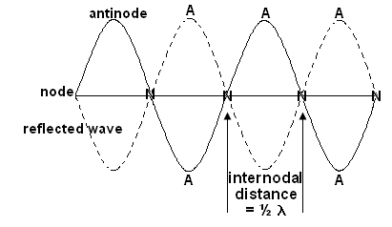

Standing Waves in strings. Examples: vocal cords, guitar strings
Your teacher will help you complete the information below.

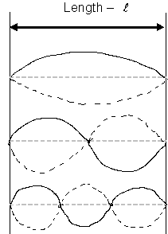
wavelength - λ frequency - f

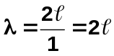

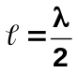Fundamental frequency f
or

Second harmonic 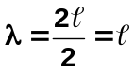 2f
(First overtone)
or = λ

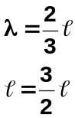
Third harmonic
(Second overtone) 3f
or

Example:
The speed of waves in a particular guitar string is 425 m s⁻¹. Determine the fundamental frequency of the string if its length is 76.5 cm. (278 Hz)

λ = 2 x 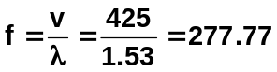
= 2 x 0.765
= 1.53 m f = 278 Hz

Standing Waves In An Open Tube
In an open tube, there is an antinode at each end so the wavelength will be twice the length of the pipe. An open ended air column has a fundamental frequency twice as high as a closed air column of the same length.

Your teacher will help you complete the information below:
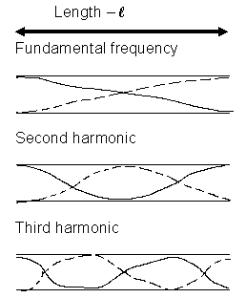
λ f

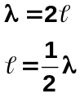

or f

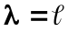 2f

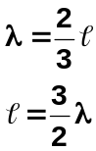

3f
or

Example: An open pipe has an effective length of 1.23 m. Calculate
- the fundamental frequency of the pipe when the speed of sound is 340 ms⁻¹
- the frequency and wavelength of the second harmonic.

Answer:
- l = 1.23 m λ = 2l f = v = 340
v = 340 ms⁻¹ = 2 x 1.23 λ 246
= 2.46 m f = 138 Hz

- for 2nd harmonic λ = l = 1.23 m OR f₂ = 2 x f₁
l = 1.23 m f = v = 340 = 2 x 138
v = 340 ms⁻¹ λ 1.23 = 276 Hz
f = 276 Hz

STATIONARY WAVES IN A CLOSED TUBE. Example: Vocal tract

A stationary wave can be set up in an air column closed at one end. If a tuning fork is sounded over the mouth of a cylinder, a compression wave will be sent down through the air inside the cylinder and will be reflected back at the closed end. When the air column is set into a steady state of motion the note of the tuning fork is greatly amplified (an example of resonance).

In this stationary wave, there must be a node at the closed end, since the layer of air there cannot move, and there will be an antinode at the open end where the air can move freely.

The fundamental stationary wave will have only this one node and antinode, as this is the simplest possible mode of vibration. The length of the air column is equal to one quarter of a wavelength of the fundamental note.

As the wavelength equals frequency times wavelength (v = fλ) it is possible to determine the velocity of sound in the column by measuring the wavelength of the stationary wave corresponding to a particular resonance frequency.
Your teacher will help you complete the information below.
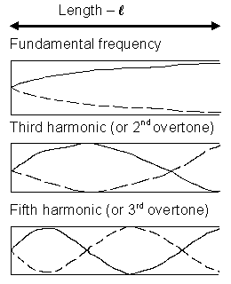
λ f
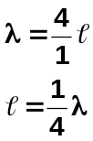

or f

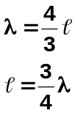

or 3f

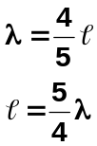

or 5f

Explain why the second and forth harmonics can’t exist in a closed pipe.
For a second harmonic to exist, you need to double the wavelength. But this can’t be done as this would produce a node at both ends, can’t have node at open end of pipe.

Example:
If you blow across the top of a coke bottle (30 cm high) it produces a fundamental frequency of 256 Hz. What is the speed of sound in the bottle?

f = 256 Hz v = fλ
- = 0.3 x 4 = 256 x 1.2
- = 1.2 m = 307.2 ms⁻¹

Example:
A closed pipe is vibrating in its 3rd harmonic with a frequency of 768 Hz. (v = 346 ms⁻¹)
a. What is the fundamental frequency of the pipe?

3rd harmonic = 3f₁ 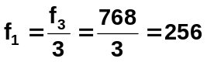Hz

fundamental f = 256 Hz

b. What is the length of the pipe in its fundamental frequency? (Speed of sound in air 346 ms⁻¹)

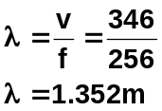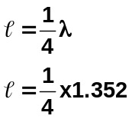

= 0.338 m

Example:
Lucy is blowing air over the end of an organ pipe. When she blows softly across the end, a microphone connected to a C.R.O. shows a frequency of 188 Hz. When she blows over the pipe a little harder, a frequency of 376 Hz is shown on the screen. The speed of sound on this particular day is 332 ms⁻¹.
- Is the pipe open at both ends or open at one end and closed at the other?

ratio f = 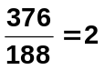

As f is doubled it must be an open pipe as only open pipes have even harmonics.

- What is the length of the pipe?

λ = 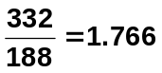 m
assuming f is fundamental,

= ½ λ
= ½ x 1.766
= 0.883 m

Do QUESTION SET TWO Questions starting below and on the next page.

Exploring Physics Stage 3:
- Experiment 10.2: Resonance in strings
- Experiment 10.3: Resonance in air columns

Set 10: Wave Behaviour pages 122 to 125

QUESTION SET TWO: Standing Waves, etc. Answers page 35 of this workbook
(Unless told otherwise, use speed of sound in air as 346 m s⁻¹)

- Why is it important that the currents supplied to two loud speakers in a stereo pair are in phase?
- Draw a diagram showing a guitar string vibrating in its third harmonic. Label the nodes and antinodes.
- Copy and draw in the resultant wave.

- A guitar sting is 0.700 m long and is played so that it vibrates in its fundamental frequency. What would be its wavelength if it were played so as to vibrate in its 5th harmonic.?
- On a day when the speed of sound is 343 ms⁻¹, a source emits sound of wavelengths 2.80 m and 3.10 m in air. How many beats per second will be heard?
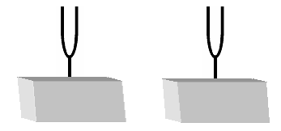
- Explain the difference between natural and forced vibrations. Include examples with your answer. How is this related to resonance?
- Two identical tuning forks are set up on boxes open at one side as shown below with the open sides facing each other. The first tuning fork is struck, then stopped from vibrating. A listener notices that the second tuning fork is now sounding even though the two boxes are not touching. Name and explain this phenomena.
- A large organ pipe is 2.20 m long and open at both ends. Find its fundamental frequency.
- The shortest length of a tube, closed at one end, which resonates to a tuning fork of frequency 326 Hz is 0.260 m.
  - What is the wavelength of the note emitted by the fork?
  - What is the speed of sound in air in this case?
- A crude whistle can be made by drilling some holes in a cylinder of metal and flattening one end to act as a mouthpiece. The mouthpiece acts as a closed end while the other end can be considered to be open. The instrument is played in a room in which the temperature is 25⁰C.
  - With all the holes covered the whistle produces a fundamental note of 152 Hz when blown gently. What is the wavelength of the fundamental note?
  - What is the effective length of the whistle?
  - When the fundamental note is sounding at which position (mouthpiece end, open end or halfway along the whistle) would the amplitude of vibration of the air molecules be at its maximum?
  - What is the wavelength of the third harmonic played on the instrument?
- The distinguishing quality of the human voice depends on the presence of harmonics (or formants) in the sound spectrum.
  - What are harmonics?
  - The closed pipe is used as a model for the human vocal system. If you produce a vocal sound having a fundamental frequency of 665 Hz, what will be the frequencies of the next two higher harmonics?
PITCH, LOUDNESS AND QUALITY
Sometimes terms are used in music that relate to the information you have already learnt. You will need to be able to relate these terms to your knowledge.

- Pitch relates to frequency ➔ high frequency = high pitch.
- Loudness is related to amplitude ➔ high amplitude = loud sounds.
- Quality ➔ relates to the number of harmonics sounded simultaneously by an instrument. A piano playing an ‘A’ note sounds different to a guitar playing an ‘A’ note because each instrument produces a different number of harmonics for the same fundamental frequency (note).

NOISE AND MUSIC

While the difference between noise and music can sometimes be very subjective, in general, the following definitions apply:

Music:
Vibrating body vibrates with regular frequency and a definite pitch. Usually pleasant to the ear.

Noise:
Body that produces vibrations that do not have a regular frequency. Usually unpleasant to the ear.
Outcome 5
Describe and explain the nature and properties of electromagnetic waves, including the concept of light as a wave of changing electric and magnetic fields, and its wave and particle properties.

Electromagnetic Radiation
- Produced by oscillating electric and magnetic fields at right angles to each other.
- Different types of oscillations produce different types of electromagnetic radiation depending on their frequency (or wavelength).
- All electromagnetic radiation travels at the speed of light (3.0 x 10⁸ ms⁻¹) and in straight lines.

Properties Of Electromagnetic Radiation
- Radiation travels in straight lines. Can travel through a vacuum or transparent media.
- Speed of radiation in vacuum is same as light – 3.00 x 10⁸ ms⁻¹ (maximum speed)
- Travels at different speeds in different medium, the denser the medium the slower the wave moves.
- Both wave-like and particle-like in nature – dual nature of electromagnetic radiation.
- Particles travel in wave-like motion. Work by Huygens (1629 – 1695) showed wave-like properties (reflection, refraction, diffraction). Wave-like properties also shown by work of Thomas Young (double slit experiment) which showed interference patterns producing light and dark areas on screen.
- Work by Einstein (1879 – 1955) showed particle properties – photoelectric effect. Light can cause electrons to be ejected from some metal surfaces. Particle-like also shown by spectra.
- As wave-like, can use wave formula in calculations; v = fλ
- Low energy radiation e.g. radio waves, are more wave-like while high energy e.g. gamma rays are more particle-like. High energy waves are also ionizing.
- Bundles of light energy (or any electromagnetic wave) known as PHOTONS, energy each particles contains is called a QUANTUM

Major Regions of Electromagnetic Spectrum

wavelength increasing
Cosmic Rays | Gamma Rays | X-rays | Ultra-violet | Visible  light  violet - red | Infra-red | Micro-waves | Radio waves
frequency and energy decreasing
Colour | Wavelength (nm)
red | 750 – 620
orange | 620 – 590
yellow | 590 – 580
green | 580 – 500
blue | 500 – 460
indigo | 460 – 450
violet | 450 – 400

NOTE: Actual values of frequency and wavelength range in Formulae and Constant sheet.

Application, Risks and Benefits:
Region | Production | Applications | Risks
Radio Waves | Oscillating electrons in wires | Communication | Unknown
Microwaves | Magnetron – high frequency electrons | Cooking, radar, telecommunications | Some cell damage
Infra Red | Oscillating electrons in molecules or atoms | Remote controls, night vision, camera auto focus | Cause heating
Visible | Oscillating electrons in molecules or atoms | Photography, vision | unknown
Ultra Violet | Oscillating electrons in molecules or atoms | Special lighting | Cause of skin cancer, sunburn and alters cell structure
X-rays | Rapidly decelerating electrons | Medicine, finding leaks in pipes, tracing fatigue in metals | Cause cancer and damage cells
Gamma Rays | Oscillation of charges within nuclei | Production of radioisotopes | Cause cancer and damage cells

Questions to answer:
- Explain how different types of electromagnetic radiation are produced. ___________________
Produced by oscillating electric and magnetic fields at right angles to each other.
Different types of oscillations produce different types of electromagnetic radiation depending on their frequency (or wavelength).
- What is the speed of all electromagnetic radiation? 3 x 10⁸ m s⁻¹
- Explain the dual nature of electromagnetic radiation.
Electromagnetic radiation exhibits both wave-like properties such as reflection, refraction and diffraction and explains Young’s Double Slit Diffraction experiment.
Also has particle-like properties such as the Photoelectric Effect where light of a particular frequency was able to eject a photon from a target metal to create an electric current. Particle like nature also shown by spectra.
- What is a photon? Bundles of energy which travel in waves. Energy each photon contains is called a quantum and this determines the frequency of the electromagnetic radiation.
- Which is more wave-like, gamma ray or microwaves? microwaves
- Where would you find high energy electromagnetic radiation? left side eg. gamma rays

Outcome 7
Classify emr spectra as emission spectra and absorption spectra and as line, broadband and continuous spectra.

SPECTRA

Type of Spectra
Spectra are classified into two main types, emission and absorption spectra. The essential difference in the two types of spectra is the means by which it was produced in the first place.

- Emission spectra are that which is obtained by the dispersion of light coming directly from the source. This may be from the glowing gas in a discharge tube or an incandescent (glowing) solid such as a globe filament. From an astronomical point of view, these are the emissions formed from hot nebulae, quasars

- Absorption spectra are that which is obtained by the dispersion of light that has passed through some absorbing material. In this type of spectra we see black lines superimposed onto a continuous spectrum which represents the absence of light within the spectrum. The solar spectrum contains a series of black lines in an otherwise continuous spectrum.

Emission Spectra
- Emission spectra may be either line emission, band emission or continuous emission. This type of spectra is from cold nebulae, atmospheres of stars.

- Line emission – thin distinct lines of colour on black background due to distinct frequencies of atoms.

- Band emission- produces bands of thin lines due to excitement of molecules rather than atoms

- Continuous emission – light from hot incandescent solids produces a continuous spectrum including the surfaces of stars.

Absorption Spectra
Absorption spectra may be either line or band absorption.

- Line absorption – when white light is passed through a vapour or some low pressure gas, photons of the frequencies corresponding to the line emission spectrum of that gas will be absorbed. This means that black lines (or an absence of light) will be seen where bright lines would have appeared in an emission spectrum. The solar spectrum is an example and the black lines correspond to the emission lines of gases in the sun’s outer atmosphere and to some extent the earth’s atmosphere. These lines are called Fraunhofer lines (learn this!!!)

- Band absorption – similar to line absorption when light passes through coloured glass or coloured liquid solutions. Dark bands are visible within an otherwise continuous spectrum.

Practical: line emission spectra
http://www.astro.washington.edu/courses/labs/clearinghouse/labs/Spectra/spectra.html
Outcome 6 and 8 (Students should spend about 2 hours on these outcome including websites.)
Describe and apply electromagnetic radiation and the emr spectrum.
Describe and explain how astronomical observations exploit differences in properties of the various parts of the emr spectrum in order to gather more information about celestial bodies.

NOTE:
These section is well covered in text and on the Internet so it will only be briefly covered here.

Teaching Points for this Outcome:
- Ground based observations on Earth of astronomical events effectively limited to visible (optical telescopes) and radio (radio telescopes) frequencies and some IR.
- Visible, IR and radio observations show different details of the same astronomical target (e.g. mapping Milky Way with radio waves).
- Radio telescopes have poor resolution which can be increased by having multiple dishes (e.g. square kilometre array).

Practical: Herschel’s experiment showed the existence of infrared
http://coolcosmos.ipac.caltech.edu/cosmic_classroom/classroom_activities/herschel_experiment2.html

- Views of the Sun via various satellites and telescopes
- Satellites can explore parts of EM spectrum absorbed by Earth’s atmosphere
- Black body radiation—the colour of a black body changes with temperature—colour gives surface temperature of stars
Emission spectra and absorption spectra—in visible wavelengths, lines show presence of elements, bands show compounds http://outreach.atnf.csiro.au/education/senior/astrophysics/spectra_info.html#specinfodoppler

Our eyes detect visible light which is only a small percentage of the electromagnetic spectrum. Celestial bodies emit many other forms of radiation which are studied by astronomers and these methods are briefly discuss below.

Radio Astronomy

Radio astronomy is the study of celestial objects that emit radio waves. With radio astronomy, scientists can study astronomical phenomena that are often invisible in other portions of the electromagnetic spectrum such as pulsars and aspects of galaxies.

Using radio astronomy techniques, astronomers can observe the Cosmic Microwave Background Radiation, which is the remnant signal of the birth of our Universe in the Big Bang. They can also probe the “Dark Ages” before the onset of the first stars or galaxies, and study the earliest generation of galaxies. Radio astronomers analyse and explore the black holes that live at the hearts of most galaxies.
Since radio waves penetrate dust, scientists use radio astronomy techniques to study regions that cannot be seen in visible light, such as the dust-shrouded environments where stars and planets are born, and the centre of our Galaxy, the Milky Way. Radio waves also allow astronomers to trace the location, density, and motion of the hydrogen gas that constitutes three-fourths of the ordinary matter in the Universe. Closer to home, astronomers study radio frequencies from our Sun and other planets such as Jupiter.

X-Ray Astronomy (From Wikipedia, the free encyclopedia)

X-ray astronomy is an observational branch of astronomy which deals with the study of X-ray emission from celestial objects. X-radiation is absorbed by the Earth's atmosphere, so instruments to detect X-rays must be taken to high altitude by balloons, sounding rockets, and satellites. X-ray astronomy is part of space science.

X-ray emission is expected in sources which contain an extremely hot gas at temperatures from a million to hundred million kelvin. In general, this occurs in objects where the atoms and/or electrons have a very high energy.

It is known that such X-ray sources are compact stars, such as neutron stars and black holes. The energy source is gravity. Gas is heated by the fall in the strong gravitational field of celestial objects.

Many thousands of X-ray sources are known. In addition, it appears that the space between galaxies in a cluster of galaxies is filled with a very hot, but very dilute gas at a temperature between 10 and 100 megakelvins (MK). The total amount of hot gas is five to ten times the total mass in the visible galaxies.

From the combination of images and spectra from X-ray Astronomy, we can build up detailed models of what the conditions are inside a cluster of galaxies or close to a black hole by matching what we see to the model.

Infra-red Astronomy

Infrared astronomy is the branch of astronomy and astrophysics that studies astronomical objects visible in infrared (IR) radiation. The wavelength of infrared light ranges from 0.75 to 300 microns.

Infrared astronomy began in the 1830s however early progress was limited, and it was not until the early 1900s that conclusive detections of astronomical objects other than the Sun and Moon were detected in infrared light. After a number of discoveries were made in the 1950s and 1960s in radio astronomy, astronomers realized the information available outside of the visible wavelength range, and modern infrared astronomy was established.

Infrared and optical astronomy are often practiced using the same telescopes, as the same mirrors or lenses are usually effective over a wavelength range that includes both visible and optical light. Both fields also use solid state detectors, though not the specific type of solid state detectors used are different. Infrared light is absorbed at many wavelengths by water vapor in the Earth's atmosphere, so most infrared telescopes are at high elevations in dry places, above as much of the atmosphere as possible. As they are not affected by light, they can be used during the day as well as at night. Many new stars, galaxies, asteroids, and quasars have been discovered using IR Astronomy.

Practical: Herschel’s experiment showed the existence of infrared
http://coolcosmos.ipac.caltech.edu/cosmic_classroom/classroom_activities/herschel_experiment2.html

Ultra-Violet Astronomy

Ultraviolet astronomy is the study of astronomical objects in the ultraviolet portion of the electromagnetic spectrum. Because Earth's atmosphere prevents ultraviolet radiation from reaching its surface, ground-based observatories cannot observe in the ultraviolet. Only with the advent of space-based telescopes has this area of astronomy become available for research.

Ultraviolet radiation has a shorter wavelength and more energy than visual radiation, and much of ultraviolet astronomy therefore centers on energetic processes in stars and galaxies. Hot regions of stellar atmospheres, for example, invisible to optical telescopes, reveal a wealth of information to the ultraviolet telescope. The crowded, violent regions at the centers of some galaxies are also prime targets for ultraviolet telescopes.
Ultraviolet line spectrum measurements are used to discern the chemical composition, densities, and temperatures of the interstellar medium, and the temperature and composition of hot young stars. UV observations can also provide essential information about the evolution of galaxies.
Outcome 9
Explain and interpret line emission spectra, line absorption spectra and ionisation using the bohr model of the atom and the concepts of ground and excited states, photons, quanta and energy level transitions—this includes applying the relationships: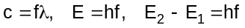.

Spectra of Gases and Bohr’s Model of the Atom

Problems with pre Einstein Physics
- Electrons are charged particles moving in circular motion, therefore according to classical physics (prior to 19th century)
- accelerating charges must generate electromagnetic radiation
- energy is sent off into space
- therefore atom should collapse but obviously did not!!!!!!!

- No explanation for spectrum emitted by a gas excited by an electric current
- gasses consisted of separate frequencies e.g. hydrogen, (see below) instead of continuous frequency e.g. sun

- Many other problems that classical physics could not explain
- axis of mercury changing
- sun’s continuous energy
- rocks producing energy although none put in.

Solution
1905 Einstein solved many of these problems by two papers that revised existing theories and laid the ground for Modern Physics.

Particle-like nature of electromagnetic radiation
- light towards blue end produces electricity, other end didn’t (photoelectric effect)
- intensity (brightness) of light made no difference
- Einstein explained by considering light as photons of energy of certain frequency. Only if the frequency were high enough can electrons be emitted.

Line Emission Spectrum.
When hydrogen gas is excited (energy added), coloured lines on black background can be seen when the hydrogen is looked at using a spectrometer. These lines corresponded to certain frequencies only and were different for different gases.

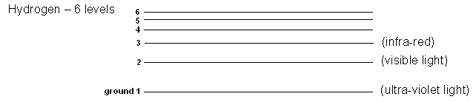

Studies found that the lines were due to the electrons being excited and jumping to higher energy levels. They quickly returned to their original level by releasing the energy given to them in the form of electromagnet radiation. Depending on the amount of energy, different frequencies of light were emitted and hence the different colours. From the energy level diagram above, it can be seen that if an electron falls to level 3, it gives out infra-red light, level 2 is visible light, and level 1 is ultra-violet light. Line emission spectrums were explained by Bohr using hydrogen gas.

While other gases tend to be more complex (more electrons to gain and lose energy), the basic theory generally holds true.

The Bohr Model Of The Hydrogen Atom
Niels Bohr put forward a theory concerning the structure of the atom. His theory helps physicists to better understand the behaviour of electrons within an atom.

Main Ideas

- Hydrogen atom consists of a positive nucleus with one negative electron orbiting.
- Quantum hypothesis – electrons only exist in definite and discrete orbits of particular energy (known as their ground state), although an electron can move temporarily to a higher orbit if given enough energy.
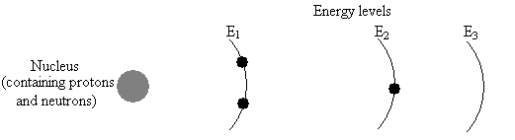
Note: E₂ is a higher energy than E₁ as it is further from the nucleus.

- Energy emitted when electron return to a lower level from a higher level. Frequency of energy determined by difference in energy level.

E₂ - E₁ = hf Where E₂ = initial higher energy level
E₁ = final energy level
h = Planck’s constant
f = frequency
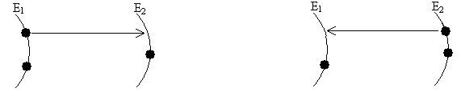
Energy is required to ‘excite’ electron in ground state to higher energy level.
Energy released as E.M. radiation when returning to ground state.

4. Bohr’s model accounts for coloured spectral lines produced by hydrogen.
1. Hydrogen atom has six energy levels.
2. Only four transitions result in visible light, those ending in the second level.
3. Transitions ending in level 3 produce infra-red radiation and level one produce ultra-violet
radiation.

ionization
Loss of electron – occurs when the electron is excited beyond energy levels.

E₃

E₂
energy input
Energy transitions – energy is released when the electron returns to ground state.


E₁

(ground state)

Relationships
It’s now time to look closely at the mathematical relationships involved in atoms.
- As electromagnetic radiation is wave-like, wave formula applies:

c = λ f where c = speed of wave = 3.0 x 10⁸ m s⁻¹
λ = wavelength in metres (m)
f = frequency in hertz (Hz)

- Occasionally you have to deal with intensity of light beam. The intensity is the energy transferred per square metre per second:

I = E where I = intensity in W m⁻²
At E = energy (J)
A = area (m²)
t = time (s)

- Each photon of electromagnetic radiation has its own characteristic frequency called a quantum of energy. This characteristic frequency can be found using the formula

E = hf where E = energy in joules
h = Planck’s constant = 6.63 x 10⁻³⁴ J s
f = frequency in hertz (Hz)

Example:
A local radio station transmits signals at a frequency of 92.9 MHz.
a. Calculate the energy of each photon produced.
b. If the power output of the radio signal is 1.2 kW, how many photons per second are transmitted?

Answer a:
E = hf
= 6.63 x 10⁻³⁴ x 92.9 x 10⁶
= 6.16 x 10⁻²⁶ J

Answer b:
P = 1200 W = 1200 joules per second
i.e. 6.16 x 10⁻²⁶ J represents 1 photon
1200 J represents x photons
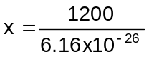
= 1.95 x 10²⁸ photons per second.

Question:
Light of wavelength 4.53 x 10⁻⁷ m is emitted when an electron moves from an energy level of 6.89 x 10⁻¹⁹ J to another energy level closer to the ground state. What is the energy of this level?

ΔE = (h x c) ÷ λ
= (6.63 x 10⁻³⁴ x 3 x 10⁸) ÷ 4.53 x 10⁻⁷
= 4.39 x 10⁻¹⁹ J

The level to which the electron has moved is to
(6.89 x 10⁻¹⁹ – 4.39 x 10⁻¹⁹)
= 2.5 x 10⁻¹⁹ J

Interpretation of Line Emission Spectra

ionization
Loss of electron – occurs when the electron is excited beyond energy levels.

E₃

E₂
Energy transitions – energy is released when the electron returns to ground state.

E₁
(ground state)

- electrons are usually at ground state
- electron given energy and jumps to higher level – this is when electron is in excited state.
- on return to ground state releases energy (as photon of electromagnetic radiation)
- energy is usually stated in electron volts (eV) → 1 eV = 1.60 x 10⁻¹⁹ J
- energy is given as a negative value (e.g. E₁ = -13.6 eV). The negative sign indicates lower energy level than one above.
- Energy released is given by E₃
different levels.
- Formulae E = hf and c = fλ
E _{released} = E₃ – E₁ E₂
See example next page.
E _{released} = E₂ – E₁
E₁ E₁

Some Important Terminology

You must understand the meaning of the following terms. Use these notes and your study guide to help in your definitions.

Ground State lowest energy level of an atom

Excited Atom atom which has an electron in an excited state – not in ground state

Photon bundle of electromagnetic energy

Quantum amount of energy each photon has

Energy level different energy levels in an atom to which an electron can jump

Ionisation energy if given enough energy, an electron can escape the atom – this is the ionisation energy

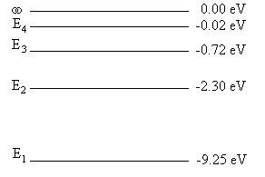
Example:
The following diagram represents the energy levels possible for a particular atom.
- How many possible energy transitions are there?
- What is the significance of the ∞ energy level?
- Which transition will give the
  - lowest frequency?
  - Shortest wavelength?
- Use the electromagnetic spectrum to determine the type of electromagnetic radiation emitted in (i) and (ii) above.

Answers:
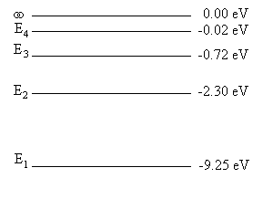
- There are six, see diagram to the right.

- Ionization occurs. Electrons are lost from the atom.

- (i) lowest frequency = lowest energy.
i.e. E₄ - E₃ = 0.720 – 0.020
= 0.700 eV
= 0.700 x 1.6 x 10⁻¹⁹
= 1.12 x 10⁻¹⁹ J

E = hf
1.12 x 10⁻¹⁹ = 6.63 x 10⁻³⁴ x f
f = 1.69 x 10¹⁴ Hz

(ii) shortest wavelength = highest energy.
i.e. E₄ - E₁ = 9.25 – 0.020
= 9.23 eV
= 9.23 x 1.6 x 10⁻¹⁹
= 1.48 x 10⁻¹⁸ J

E = hc
λ
1.48 x 10⁻¹⁸ = 6.63 x 10⁻³⁴ x 3 x 10⁸
λ
= 1.35 x 10⁻⁷ m

- Lowest frequency is in infra red region and shortest wavelength is in ultraviolet region.

Exploring Physics Stage 3:

Experiment 11.1: Observing light sources
Experiment 11.2: Detecting Infrared Radiation
Experiment 11.3: Detecting Ultraviolet Radiation

Problem Set 11: Photons

Experiment 12.1: Line spectra
Experiment 12.2: Band spectra

QUESTION SET THREE: Answers on page 37 of this workbook

- What name is given to the lowest energy level?
- What is meant by saying that an electron is in an excited state?
- There are six levels in the hydrogen atom: -13.6 eV, -3.40 eV, -1.51 eV, -0.85 eV, -0.54 eV, -0.48 eV. Explain why the energies are given as negative numbers. What would happen if more than 13.6 eV were added to the electron? What name do we give to this occurrence?
- If the hydrogen atom in question 4 was in an excited state with an electron at the E₃ level, what would be the highest frequency photon it could emit as it returned to the ground state?
- What is the frequency, wavelength and’ colour of the light emitted when ‘an electron moves from a level of energy equal to 8.43 x 10⁻¹⁹ J to an energy level of 3.95 x 10⁻¹⁹J?
- The first three energy levels of an atom are at 1.98 x 10⁻¹⁹J, 4.86 x 10⁻¹⁹J and 8.65 x 10⁻¹⁹J. An electron transition results in the release of a photon of frequency 5.72 x 10¹⁴ Hz. Between which energy levels did the electron move?
- The electron in a hydrogen atom can exist at various energy levels, E1:ground state, 0.700 x 10⁻¹⁹ J, E2: 17.0x 10⁻¹⁹J, E3: 20.0x 10⁻¹⁹J and E4: 21.8 x 10⁻¹⁹J.
  - How many lines in the emission spectrum of atomic hydrogen can be predicted? Draw them.
  - Of all these lines, which has the shortest wavelength and what is this wavelength? What type of radiation is this?
- The wavelength of a blue line in the Balmer series of the hydrogen spectrum is 4.34 x 10⁻¹⁷ m. Given in electron volts, what is the energy difference between the two energy levels responsible for this line?
- A ship building company uses a powerful laser to cut steel plate. The laser has a power of 900.0 W and produces infra red radiation with a wavelength of 1.00 x 10⁻⁶ m.
  - What is the energy per photon produced?
  - How many photons are produced per second?

Outcome 10
Explain fluorescence and the generation of x-rays—this includes applying the relationships: .

Applications of Emission Spectra - Fluorescence

Fluorescence is the emission of electromagnetic radiation light by a substance that has absorbed radiation of a different wavelength. Generally, the absorption of light of a certain wavelength results in the emission of light with a longer wavelength and lower energy.

In fluorescence, the emission and absorption follow each other quite rapidly, so that fluorescence lasts only as long as the illuminating radiation is on. In phosphorescence, however, the emission occurs quite slowly and persists for a long time after the illuminating radiation has been turned off.

Fluorescent materials often emit light without a significant change in temperature. The diagram below shows the process of fluorescence.

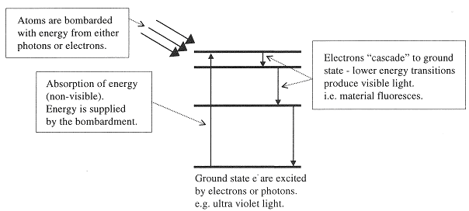

A common example of fluorescence – fluorescent tubes.

  - An electron beam excites atoms of the gas inside the fluorescent tube. This gas is at a low pressure so as to produce an emission spectrum.
  - The excited gaseous atoms emit ultra violet light as they return to their ground state.
  - The white powder on the side of the tube (phosphor) absorbs the ultra violet light emitted by the gas.
  - The atoms in the white powder return to their ground state via a series of energy transitions and, as a result, they emit visible light – in other words, they fluoresce.

Questions on Fluorescence:
1. Explain how fluorescence works.
2. In your own words, explain how a fluorescence tube works
3. Explain why fluorescence is used in fluorescent ink.
4. Some soap powders are claimed to clean “whiter than white”. Explain why they might make the
material appear to be very white.
X-rays

Generation of X-rays:
X-rays are high frequency electromagnetic waves (or photons) which are produced when high speed electrons strike a metal target. They were first discovered by Roentgen in 1895 while experimenting with a discharge tube. He realised that they were some kind of very penetrating ray but knew little else about them and so decided to call them X-rays.

X-rays are produced in an X-ray tube where:
- electrons are heated and then accelerated to very high velocities by voltages of about 50kV.
- the electrons strike a metal target anode (often copper or tungsten)
- the potential energy from the electrical supply results in the electrons gaining kinetic energy
- they strike the target emitting photons in the X-ray region.
- electrons also lose energy during these collisions forming a wide low intensity emission called bremsstrahlung (braking radiation.
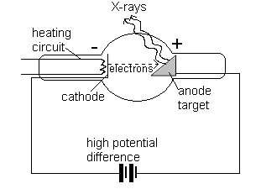
The cathode is a source of electrons when heated. Once produced , the electrons are accelerated through a large potential difference (approximately 50kV) towards the anode target. | The anode target is made of copper and tungsten (to prevent melting). Electrons from the cathode are rapidly decelerated as they collide with the atoms in the anode. These collisions produce X-rays. The electrons undergo several collisions with target atoms resulting in different wavelength X-rays being produced.

- X-rays are high frequency electromagnetic radiation (dangerous in long exposures).
• X-rays have both high energy and strong penetrating powers and are produced in an X-ray tube.
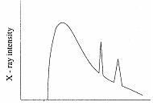
- Although the rapidly decelerating electrons produce X-rays, the majority of the electrons’ kinetic energy is converted to heat energy during the collisions.

While giving up their energy, the electrons can undergo several collision within the metal anode target. As a result, several photons of different energies are produced. The diagram shows characteristic peaks of an X-ray spectrum from an X-ray tube which are related to the type of atoms in the metal.

To summarise X-rays are generation:
- Heated filament emits electrons
- Very high PD across cathode and anode
- Electrons accelerate quickly towards anode target
- Rapid deceleration when they hit target means energy converted to X-rays
- Two types of X-rays
  - as described above
  - spikes in ionise electrons in dense materials
QUESTION SET FOUR Answers on page 39 of this workbook

- Explain the dual nature of electromagnetic waves and the evidence for this dual nature.

- When looking at the sun through a spectroscope, a spectrum can be seen which has thin black lines on it. What is the name given to this type of spectrum? What is the name given to these lines and why do they occur?

- What is the frequency of an electromagnetic wave with a wavelength of 12 m?

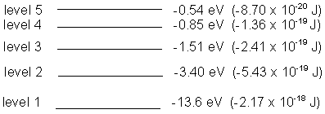
- The diagram shows the energy levels for a hydrogen atom.
- What does eV stand for, and how do you convert eV to joules?
- An electron in ground state is excited to the third level and returns to the ground level. How many possible downward transitions are possible for this electron?
- Calculate the energy of the photon emitted in each case in joules.
- Determine the wavelength of each photon and hence its colour or region of the
electromagnetic spectrum.
- An electron bombarded an atom and resulted in a photon of wavelength 4.0 x 10⁻⁶ m being emitted. Which downward transition resulted in this occurring?

- Two beams of light, one blue (λ = 4.8 x 10⁻⁷ m) and the other yellow (λ = 5.9 x 10⁻⁷) are both rated at 100 W. Which beam will emit the greatest number of photons per second?

- Minerals such as calcite and fluorite can often be fluorescent due to the presence of rare earth elements which can absorb short wavelength light and then re-emit it at lower wavelengths. In one such occurrence photons with a frequency of 1.15 x 10¹⁵ Hz are absorbed and then the energy is released in two separate photons. If one of the photons emitted has an energy of 2.07 eV,
- explain how fluorescence occurs
- determine the energy of the other photon emitted
- determine the wavelengths of the two photons emitted
- determine the part of the electromagnetic spectrum or colour that these photons belong to.
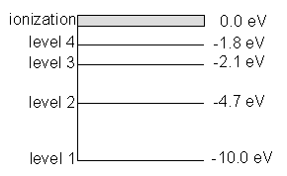
- Look at the energy level diagram below of a particular atom:
- Why are the energy levels shown as negative?
- Assuming that the electron doesn’t ionize, how many downward transitions are possible? Show them on the diagram.
- What type of radiation is produced when an electron moves from level 4 to level 3?
- How much radiation is needed for the electron to ionize?
- What is the wavelength of a photon produced when an electron at ground state is excited to level 2 and returns.
- A photon of energy 12.5 eV enters the atom in the ground state. How much energy is used to ionize the atom and what would be the velocity of the ejected electron?
Exploring Physics Stage 3:
Set 12: Atoms and X-rays
Investigation 12.3: Fluorescence
Outcome 11
Extend the concept of the subatomic particle to include neutrinos and quarks.

Going deeper into the atom

Quarks
Quarks and Leptons are currently recognised as the fundamental particles of matter. Contemporary understanding of matter considers quarks as the building blocks of protons and neutrons and leptons for particles such as electrons. There are six quarks and six leptons which are currently thought to be the building blocks of our universe although many more subatomic particles are being detected and new ways of classifying them are being developed. One method of classifying subatomic particles is as mesons, leptons and hadrons.

Hadrons are those particles that interact via strong nuclear forces such as protons and neutrons.
Leptons interact with weak nuclear forces and include electrons and neutrinos.

Quarks and leptons are separated according to their flavour (or type).
- Quarks are separated into three pairs: up / down, top / bottom, strange / charm
- Leptons are separated into: electron, muon, neutrino, tau, electron-neutrino, tau-neutrino
As you can see, the electron, which you are familiar with, is a lepton.

Quarks join together to form hadrons such as protons and neutrons. Quarks also have anti-particles called antiquarks and it is interesting to note that quarks and antiquarks are the only two fundamental particles that interact through all four fundamental forces of physics - strong nuclear forces, weak nuclear forces, electromagnetism and gravitational forces.

Quarks have the unusual characteristic of having a fractional electric charge unlike protons and electrons.

Up, charm and top quarks (referred to as up-type quarks) have +2/3 electric charge
Down, strange and bottom (referred to as down-type quarks) have -1/3 electric charge

The charge on a hadron is determined by the quarks that form it. For instance, a proton is made of an two up and one down quark:  +  -  = +1 and as we know, the charge on a proton is +1.

Leptons
There are six leptons, three of which have electrical charge and three of which do not. They are believed to be point-like particles without internal structure. The electron is a charged lepton. The other two charged leptons are the muon (μ) and the tau (τ), which are charged like electrons but have more mass. The other leptons are the three types of neutrinos (ν). They have no electrical charge, very little mass, and they are very hard to find. There are three types of neutrinos and these are detected in beta decay.
Unlike quarks, leptons are solitary particles and hard to see. For each lepton there is a corresponding antimatter antilepton. The anti-electron is given the name “positron” and has a charge of +1.

Leptons |  | Quarks
Electron | e | Up | u
Electron-neutrino | ν_{e} | Down | d
Muon | μ | Charm | c
Muon-neutrino | ν_{μ} | Strange | s
Tau | τ | Top | t
Tau-neutrino | ν_{τ} | Bottom | b

Table Reference: WACE Study Guide 3A & 3B PHYSICS: Michael Lucarelli

Answers to QUESTION SET ONE: Waves and Wave Behaviour.

- An umpire blows his whistle when he is at the opposite end of a football ground from you. Estimate the time delay between the moment you see the whistle being blown and when you hear it.
s = 100 m (between 50 and 150 m OK) v = s/t
v = 346 m s⁻¹ t = s/v
= 100/346
t = 0.29 s
(time for light about 3.33 x 10⁻⁷s so can ignore)
make sure you have no more than 2 significant figures in answer

- a. What does the term “displacement” mean when applied to sound waves (2000 TEE)
Distance from mean position of a vibrating object, amplitude of vibration.

b. Sketch graphs of displacement versus time for a low pitch graph and a high pitched graph.
The assumption is that the amplitude is the same so only the wavelength changes.
A high pitch sound has a high frequency say 10 000 Hz and a low pitch sound has a low frequency say 100 Hz.
A displacement vs time graph show period.
T (high) = 1/10 000 = 1 x 10⁻⁴ s while T (low) = 1/100 = 0.01 s
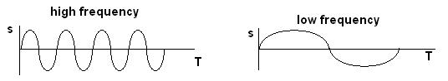

- Do sound waves diffract? If you wanted to try and demonstrate that your answer is correct, how would you try to do this? Include a diagram with your answer.
Sound waves do diffract e.g. standing beside an open door, hear what is happening inside. Here the wavelength is a similar size to the opening (door) so very small shadow region and large diffraction.

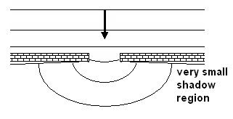
- Some examples of waves are sound, radio, water waves, and X-rays. Classify these as either mechanical or electromagnetic waves
Electromagnetic – radio and X-rays. Mechanical – sound and water waves

- A person fishing from jetty notices that the foam float on their fishing line gently bobs up and down as regular waves pass by. The person counts 13 full oscillations of the float in one minute. What is the period of the wave? (1998 TEE)
f = 13/60 T = 1/f = 1/0.217
= 0.217 s T = 4.6 s

- An example of a longitudinal wave is sound An example of a transverse wave is light
Explain the difference between longitudinal and transverse waves. (1998 TEE)
Vibrations in longitudinal waves are parallel to the progression of energy of the wave.
Vibration in transverse wave are perpendicular to progression of energy of the wave.
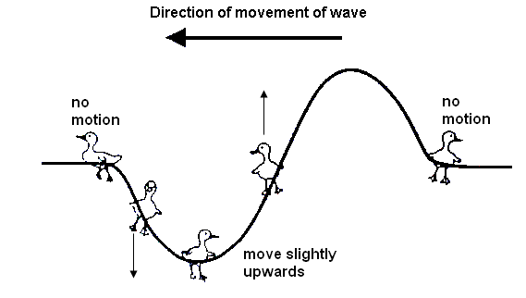
- Bridgette is watching some ducklings, which are paddling on a pond, when a wave approaches them. Use arrows to show direction of movement of each duckling at the instance shown on the diagram. If there is no movement, label “no-motion”.

- Draw a graph to illustrate amplitude and wavelength of a wave.

- Complete the following diagram to show reflection of sound from a circular reflector.

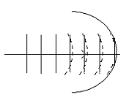

- On a calm summer evening the air near the ground is rather cool while higher up it is warmer. Sound travels faster in warm air. Using wave-front diagrams carefully show how refraction of sound can allow the noise from an aircraft to be heard quite clearly at some point far away.
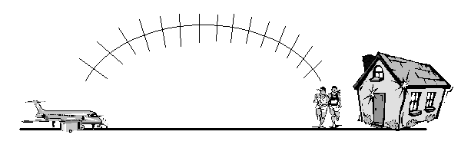
As cooler lower down, the sound bends away from the normal as it moves upwards from the aircraft as it moves faster in warmer air. This creates the bending effect.

QUESTION SET TWO: Standing Waves, etc.
(Unless told otherwise, use speed of sound in air as 346 m s⁻¹)

- Why is it important that the currents supplied to two loud speakers in a stereo pair are in phase?
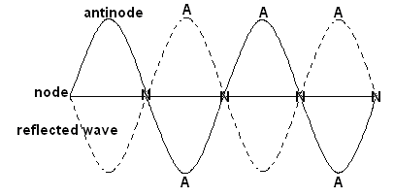
While in phase, the sound is reinforced. If out of phase, additional sound effects could be heard such as “dead spots” due to constructive and deconstructive interference.
- Draw a diagram showing a guitar string vibrating in its third harmonic. Label the nodes and antinodes.

- Copy and draw in the resultant wave.
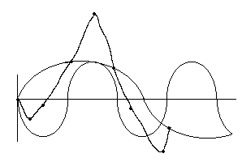
- A guitar sting is 0.700 m long and is played so that it vibrates in its fundamental frequency. What would be its wavelength if it were played so as to vibrate in its 5th harmonic?
= 0.700 m 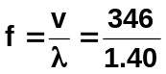 f₅ = 5 x 247.14
λ = 2 x 0.7 = 247.14 Hz = 1236 Hz
= 1.40 m = 1.24 x 10³ Hz

- On a day when the speed of sound is 343 ms⁻¹, a source emits sound of wavelengths 2.80 m and 3.10 m in air. How many beats per second will be heard?
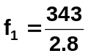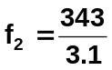
= 122.5 Hz = 110.6 Hz

f _{beats} = | 122.5 – 110.6 }
= 11.85

so 12 beats heard

- Explain the difference between natural and forced vibrations. Include examples with your answer. How is this related to resonance?
Natural is when a body vibrates in its own natural frequency e.g. a tuning fork will vibrate at its own frequency.

Forced vibration is when an object is forced to vibrate in a frequency that is not its own natural frequency e.g. a tuning fork placed on a desk . the desk is forced to vibrate at the frequency of the tuning fork and the sound heard (large surface to vibrate compared to tuning fork).

Resonance is where an object is forced to vibrate but the vibrations match those of the object – its own natural frequency. Here are vibrations are greatly increased.
- Two identical tuning forks are set up on boxes open at one side as shown below with the open sides facing each other. The first tuning fork is struck, then stopped from vibrating. A listener notices that the second tuning fork is now sounding even though the two boxes are not touching. Name and explain this phenomena.
Resonance.
The vibrating air in the first sounding box causes the air in the second box to also vibrate which in turn causes the second tuning fork to vibrate. As the tuning forks are matched, the forced vibrations are the same as the natural vibrations so they are greatly increased and we hear the second tuning fork.

- A large organ pipe is 2.20 m long and open at both ends. Find its fundamental frequency.
λ = 2 x 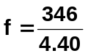
= 2 x 2.20 f = 78.6 Hz
= 4.40 m

- The shortest length of a tube, closed at one end, which resonates to a tuning fork of frequency 326 Hz is 0.260 m.
  - What is the wavelength of the note emitted by the fork?
  - What is the speed of sound in air in this case?
a. λ = 4 b. v = fλ
= 4 x 0.26 = 326 x 1.04
= 1.04 m = 339.04

- A crude whistle can be made by drilling some holes in a cylinder of metal and flattening one end to act as a mouthpiece. The mouthpiece acts as a closed end while the other end can be considered to be open. The instrument is played in a room in which the temperature is 25⁰C.
  - With all the holes covered the whistle produces a fundamental note of 152 Hz when blown gently. What is the wavelength of the fundamental note?

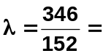 2.28 m

  - What is the effective length of the whistle?

= ¼ λ
= ¼ x 2.28
= 0.570 m

  - When the fundamental note is sounding at which position (mouthpiece end, open end or halfway along the whistle) would the amplitude of vibration of the air molecules be at its maximum?

maximum vibration at antinode so therefore at open end

  - What is the wavelength of the third harmonic played on the instrument?

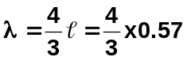 OR f₃ = 3 x 152 = 456 Hz
λ = 0.760 m 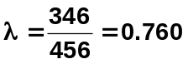m

- The distinguishing quality of the human voice depends on the presence of harmonics (or formants) in the sound spectrum.
  - What are harmonics?
Harmonic are higher frequencies of a standing wave.

  - The closed pipe is used as a model for the human vocal system. If you produce a vocal sound having a fundamental frequency of 665 Hz, what will be the frequencies of the next two higher harmonics?
f_{f} = 665 Hz as closed pipe, odd harmonic so
next = 3 x 665 = 1995 Hz
then = 5 x 665 = 3325 Hz

QUESTION SET THREE:

- What name is given to the lowest energy level? ground state
- What is meant by saying that an electron is in an excited state?
The electron has received energy and is at a higher energy level than its ground state

- There are six levels in the hydrogen atom: -13.6 eV, -3.40 eV, -1.51 eV, -0.85 eV, -0.54 eV, -0.48 eV. Explain why the energies are given as negative numbers. What would happen if more than 13.6 eV were added to the electron? What name do we give to this occurrence?

Energies are given as negative number as energy needs to be put in to raise the electron above its ground state. Also indicates that the lower energy levels have less energy than the one above.

The electron would leave the atom – known as ionisation

- If the hydrogen atom in question 4 was in an excited state with an electron at the E₃ level, what would be the highest frequency photon it could emit as it returned to the ground state?

If at level 3, then can return straight to level 1. 13.6 – 1.51, so 12.09 eV can be given out.

- What is the frequency, wavelength and colour of the light emitted when an electron moves from a level of energy equal to 8.43 x 10⁻¹⁹ J to an energy level of 3.95 x 10⁻¹⁹J?

E₂ – E₁ = fh
8.43 x 10⁻¹⁹ - 3.95 x 10⁻¹⁹ = f x 6.63 x 10⁻³⁴
4.48 x 10⁻¹⁹ = f x 6.63 x 10⁻³⁴
f = 6.76 x 10¹⁴ Hz

λ = 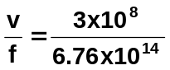
= 4.43 x 10⁻⁷ m

colour = violet

- The first three energy levels of an atom are at 1.98 x 10⁻¹⁹J, 4.86 x 10⁻¹⁹J and 8.65 x 10⁻¹⁹J. An electron transition results in the release of a photon of frequency 5.72 x 10¹⁴ Hz. Between which energy levels did the electron move?

ΔE = 5.72 x 10¹⁴ x 6.63 x 10⁻³⁴
= 3.792 x 10⁻¹⁹ J

E₃ – E₂ = 8.65 x 10⁻¹⁹ – 4.86 x 10⁻¹⁹
= 3.79 x 10⁻¹⁹ J so energy levels are E₃ → E₂
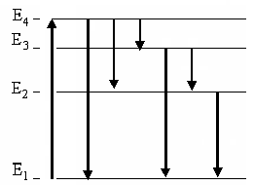
- The electron in a hydrogen atom can exist at various energy levels, E1:ground state, 0.700 x 10⁻¹⁹ J, E2: 17.0x 10⁻¹⁹J, E3: 20.0x 10⁻¹⁹J and E4: 21.8 x 10⁻¹⁹J.
  - How many lines in the emission spectrum of atomic hydrogen can be predicted for these four levels? Draw them.
six levels as shown

  - Of all these lines, which has the shortest wavelength and what is this wavelength? What type of radiation is this?

ΔE = 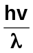 as h & v constant, ΔE ∝  so smallest λ means largest ΔE ∴ E₄ → E₁

21.8 x 10⁻¹⁹ - 0.7 x 10⁻¹⁹ = 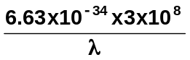
λ = 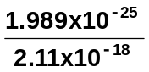 = 9.43 x 10⁻⁸ m so UV

- The wavelength of a blue line in the Balmer series of the hydrogen spectrum is 4.34 x 10⁻¹⁷ m. Given in electron volts, what is the energy difference between the two energy levels responsible for this line?

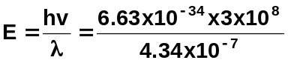

E = 4.5829 x 10⁻¹⁹ J divide by 1.6 x 10⁻¹⁹

E = 2.86 eV

- A ship building company uses a powerful laser to cut steel plate. The laser has a power of 900.0 W and produces infra red radiation with a wavelength of 1.00 x 10⁻⁶ m.
  - What is the energy per photon produced?

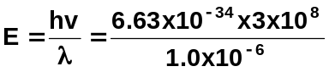
E = 1.989 x 10⁻¹⁹ J

  - How many photons are produced per second?

number of photons = 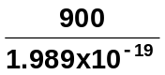

= 4.52 x 10²¹ photons / sec

QUESTION SET FOUR:

- Explain the dual nature of electromagnetic waves and the evidence for this dual nature.

Electromagnetic radiation exhibits both wave-like properties such as reflection, refraction and diffraction and explains Young’s Double Slit Diffraction experiment.
Also has particle-like properties such as the Photoelectric Effect where light of a particular frequency was able to eject a photon from a target metal to create an electric current. Particle like nature also shown by spectra.

- When looking at the sun through a spectroscope, a spectrum can be seen which has thin black lines on it. What is the name given to this type of spectrum? What is the name given to these lines and why do they occur?

Absorption spectrum: Fraunhofer lines.
Light from sun passes through sun and Earth’s atmospheres. Photons of frequencies corresponding to line emission spectrum of the atmospheres will be absorbed thus producing black lines in spectroscope. Thousands of lines have now been catalogued.

- What is the frequency of an electromagnetic wave with a wavelength of 12 m?

f = 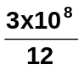 = 2.50 x 10⁷ Hz

- The diagram shows the energy levels for a hydrogen atom.
  - What does eV stand for, and how do you convert eV to joules?

eV stands for electron volt, a measure of energy.

1 eV = 1.6 x 10⁻¹⁹ J
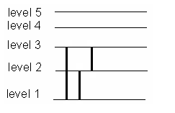
  - An electron in ground state is excited to the third level and returns to the ground level. How many possible downward transitions are possible for this electron?

three transitions

  - Calculate the energy of the photon emitted in each case in joules.

ΔE = E₃ – E₁ E₃ – E₂
= 21.7 x 10⁻¹⁹ – 2.41 x 10⁻¹⁹ 5.43 x 10⁻¹⁹ – 2.41 x 10⁻¹⁹ 21.7 x 10⁻¹⁹ – 5.43 x 10⁻¹⁹
= 19.29 x 10⁻¹⁹ J 3.02 x 10⁻¹⁹ J 16.27 x 10⁻¹⁹ J

  - Determine the wavelength of each photon and hence its colour or region of the electromagnetic spectrum.

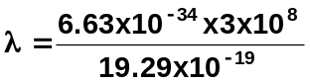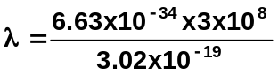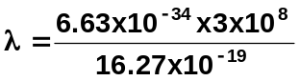
= 1.03 x 10⁻⁷ m = 6.59 x 10⁻⁷ m = 1.22 x 10⁻⁷ m
UV visible - red UV

  - An electron bombarded an atom and resulted in a photon of wavelength 4.0 x 10⁻⁶ m being emitted. Which downward transition resulted in this occurring?
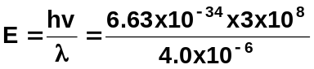
E = 4.9725 x 10⁻²⁰ J
= 0.31 eV
this is related to E₅ to E₄

- Two beams of light, one blue (λ = 4.8 x 10⁻⁷ m) and the other yellow (λ = 5.9 x 10⁻⁷) are both rated at 100 W. Which beam will emit the greatest number of photons per second?

E _{blue} = 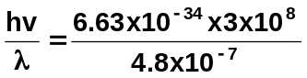 E _{yellow} = 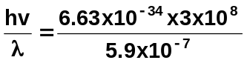
= 4.144 x 10⁻¹⁹ J = 3.3712 x 10⁻¹⁹ J

P = , but for 1.0 s, work = E x t so power = energy

No. photons = 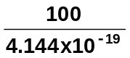 No. photons = 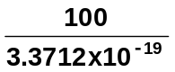
= 2.41 x 10²⁰ = 2.97 x 10²⁰

so greater number of photons from yellow light.

- Minerals such as calcite and fluorite can often be fluorescent due to the presence of rare earth elements which can absorb short wavelength light and then re-emit it at lower wavelengths. In one such occurrence photons with a frequency of 1.15 x 10¹⁵ Hz are absorbed and then the energy is released in two separate photons. If one of the photons emitted has an energy of 2.07 eV
  - explain how fluorescence occurs

Mineral contains chemicals (phosphors) that appear to produce their own light. Phosphor absorbs non-visible light (e.g. UV) which excites electrons to a higher energy level. As electrons return to ground level they undergo a transition in the visible light range emitting frequencies of visible light.

  - determine the energy of the other photon emitted

E = fh E₁ = 2.07 x 1.6 x 10⁻¹⁹
= 1.15 x 10¹⁵ x 6.63 x 10⁻³⁴ = 3.312 x 10⁻¹⁹ J
= 7.6245 x 10⁻¹⁹ J

E₂ = 7.6245 x 10⁻¹⁹ - 3.312 x 10⁻¹⁹
= 4.3125 x 10⁻¹⁹ J energy of other photon is 4.3125 x 10⁻¹⁹ J

  - determine the wavelengths of the two photons emitted

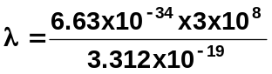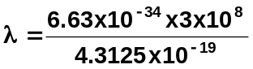
= 6.01 x 10⁻⁷ m = 4.61 x 10⁻⁷ m

  - determine the part of the electromagnetic spectrum or colour that these photons belong to.

visible – orange visible - blue

- Look at the energy level diagram below of a particular atom:
- Why are the energy levels shown as negative?

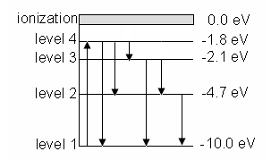
Electrons need to receive energy to move up levels

- Assuming that the electron doesn’t ionize, how many downward transitions are possible? Show them on the diagram.

6 transitions

- What type of radiation is produced when an electron moves from level 4 to level 3?

(2.1 – 1.8) x 1.6 x 10⁻¹⁹ = 6.63 x 10⁻³⁴ x f
f = 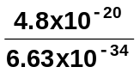
f = 7.24 x 10¹³ Hz so infra red radiation

- How much radiation is needed for the electron to ionize?

10 eV = 1.6 x 10⁻¹⁸ J

- What is the wavelength of a photon produced when an electron at ground state is excited to level 2 and returns.

ΔE = (10 – 4.7) x 1.6 x 10⁻¹⁹
= 8.48 x 10⁻¹⁹ J 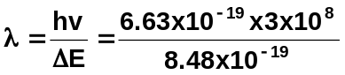

λ = 2.35 x 10⁻⁷ m

- A photon of energy 12.5 eV enters the atom in the ground state. How much energy is used to ionize the atom and what would be the velocity of the ejected electron?

10 eV is used to ionise the atom.

(12.5 – 10) x 1.6 x 10⁻¹⁹
= 4.0 x 10⁻¹⁹ J is left to give the electron its velocity

E_{k} = ½ mv²
4.0 x 10⁻¹⁹ = 0.5 x 9.11 x 10⁻³¹ x v²
v = 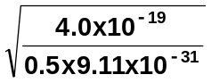

v = 9.37 x 10⁵ m s⁻¹

